Maven Interview Question –
- When I issue mvn install what all things happen in background?
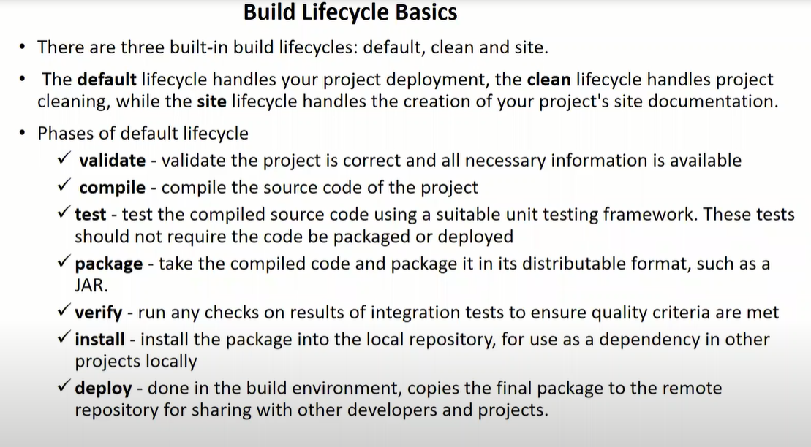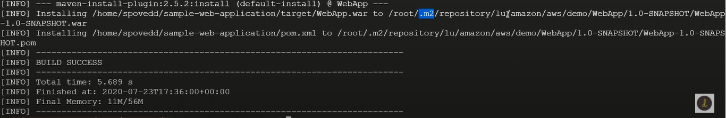2) what are the settings you need to do before running mvn deploy?
→settings.xml file you need specify the nexus repository information ( username and password of artifactory in my case I am using nexus)( server details in settings.xml file)
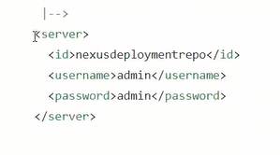
and after that in pom.xml file in <distributionmanagement> you have to specify the url & where you need to push it and id what you specify in settings.xml file should match here
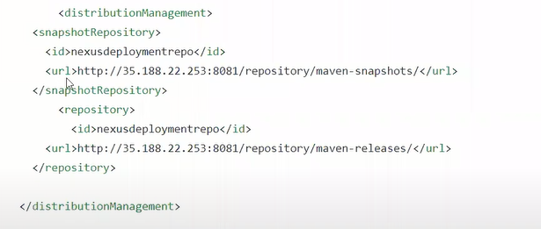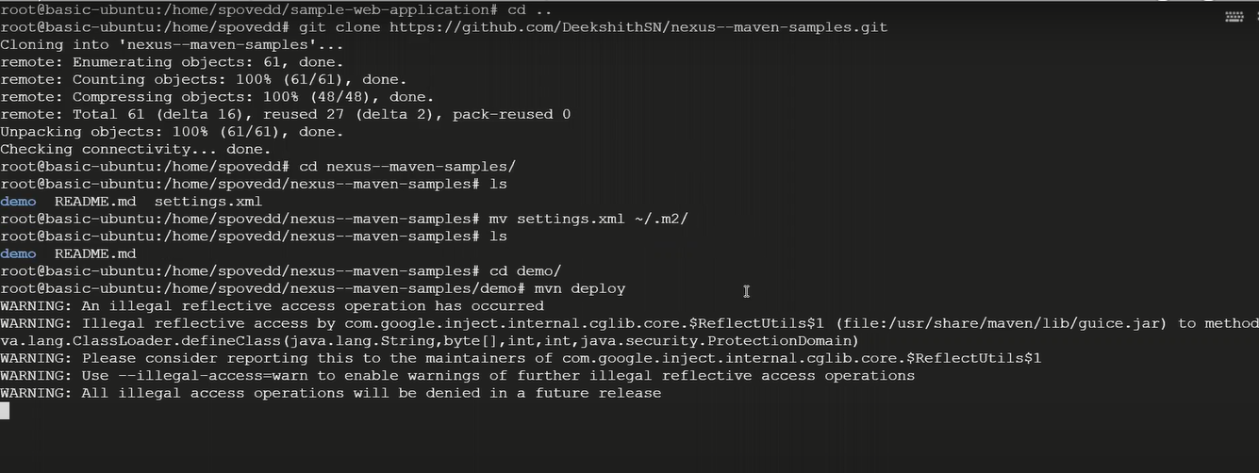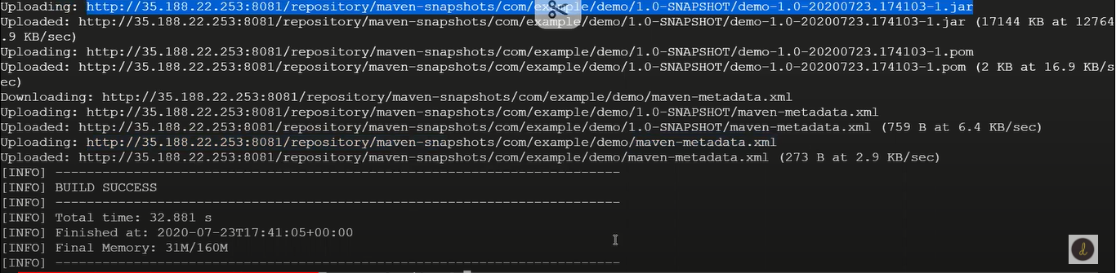it is gone execute all the steps validate , package, install etc
3)why maven takes much time for 1st execution and from 2nd execution it will take less time?
When we execute mvn command first time it will download all the dependencies and store it in .m2 folder again if you execute command it will not take much time because the stored dependencies in .m2 folder should act as cache (maven work like first it will check with local repo if it is doesn’t exist then it will download it from outside)
4) what is multi module project? Configuration you need to do in parent and child project ? what is dependency management?(Repo- Maven_Example -> dependence_managment)
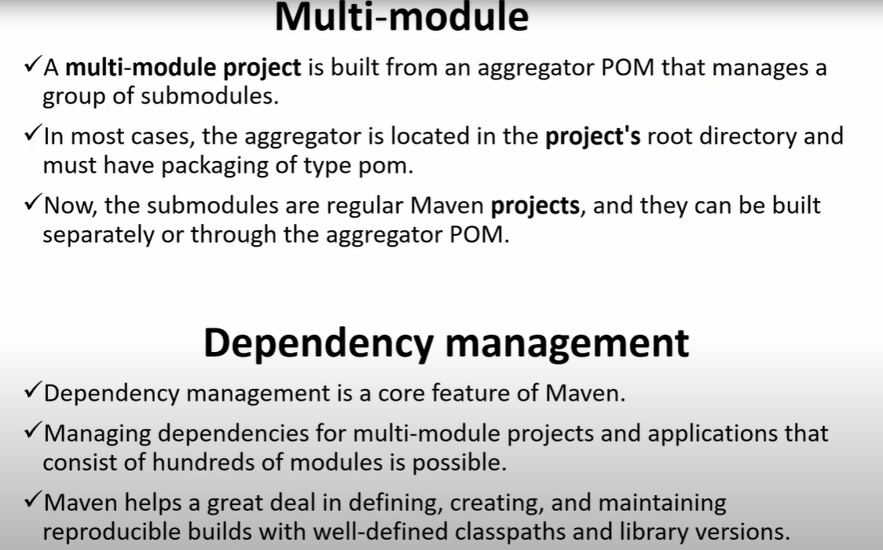
Aggregator pom the
- <packaging>pom<packaging> (it’s not jar or war)
- <modules>
<module>addition</module>
<module>substraction</module>
</modules>
In child maven project pom you need to mention
- <parent> ( the aggregater pom root id and artifact id is copied here)
<groupId>calculator</groupId>
<artifactId>calculator-main</artifactId>
<version>1.0</version>
</parent>

This are 3 setting you want to do while setting up multi module project
Dependency management= all the dependency mentioned here through <dependency>
Let say I have 10 project which are using same dependencies at the time you can use <dependencyManagement> in aggregater pom and refer this dependencies through child module pom by <dependencies> by referring just <groupid> & <artifactid> of the dependencies in aggregator pom (need not require <version> tag in child pom)

5) what is transitive dependency? (repo- Maven_Example -> dependency_management) 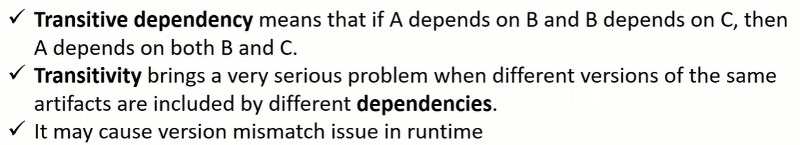
In our project we are using couple of dependencies and it has been developed by some other people while developing those dependencies they might definitely use some dependencies to achieve there task, when I build my project those dependencies also downloaded
Transitivity problem is - consider surefire ‘A’ dependency it uses surefire-api dependency of version 2.19 to achieve their task, similarly surefire ‘B’ dependency it uses same surefire-api dependency of version 3.0 to achieve their task there is a mismatch in runtime there is lot of complications

To solve those issues - <exclusions> tag in pom by using that, we can make sure that that particular transitive dependency excluded
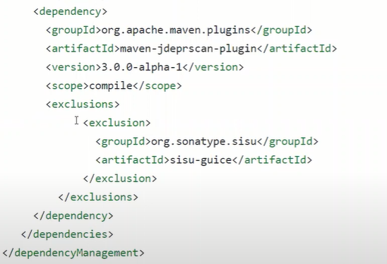
6) .m2 is local repository for maven, now I don’t want to use .m2 folder as my local repository I want to use some other folder as my local, is it possible in maven? If yes, how would you do that?
mvn install -Dmaven.repo.local=/alternate/repo/location
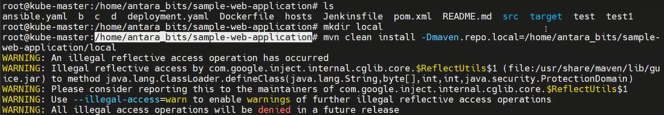
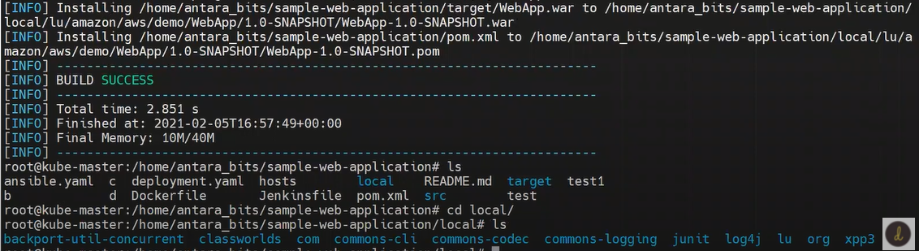
7) maven follows convention over configuration that means it assumes code should be there under src/main/java, test cases under src/tests and many more.Here my requirement is I don’t want to follow that conventions I need to use different folder structure is that possible in maven?
mvn help:effective-pom -Doutput=pom_eff.xml <= command to see super pom & cat pom_eff.xml
All this convention are defined in super pom the pom.xml will be extended from super pom, you can overwrite all this default behavior
8) What are dependency and plugin in maven? Give one example for each?
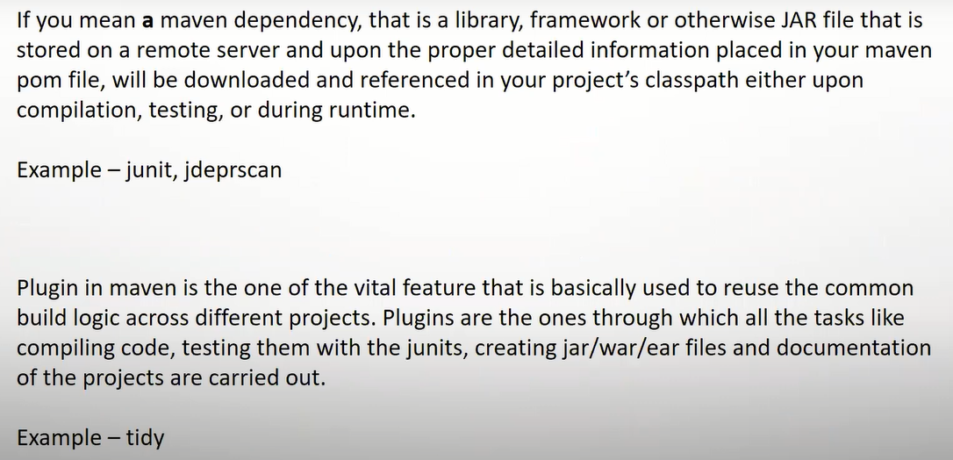 dependency (In laymen if you want to say) – working in some calculator project this calculator project have many operation like addition, subtraction etc. assume that somebody has already developed addition that you can take that operation from that project, that is what we called as dependency
Plugin – it will provide extra feature in module consider an example tidy-maven-plugin (if any mistake in the order of pom.xml it will through an error and also it will provide command to make this proper order arrangement)
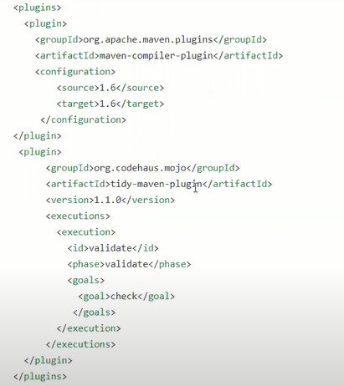
9) What are 3 build life cycles in maven?
10) In Which tag we will mention output artifact type( like jar, war or any other)?
<packaging>war</packaging> by default it is jar when you are creating jar file you don’t need to mention this
11) What are things you need to set, if you want download dependency from private repository ?
Usually we download dependencies from public repository is stored in .m2 folder if you want to download dependencies from private repo 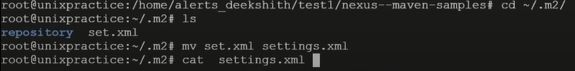
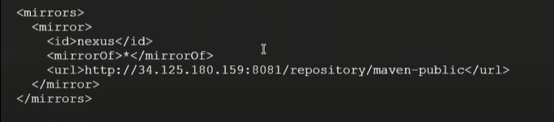
First we need to go the .m2 directory and there is file like settings.xml in this we need mention the url where I need to download it from private repo the url is mentioned in <mirrors> tag ( to pull all dependensies from private repo )
12) What are the issues you faced while working on maven projects?
13) Command to skip the test cases in maven (check lets practice repo = important) 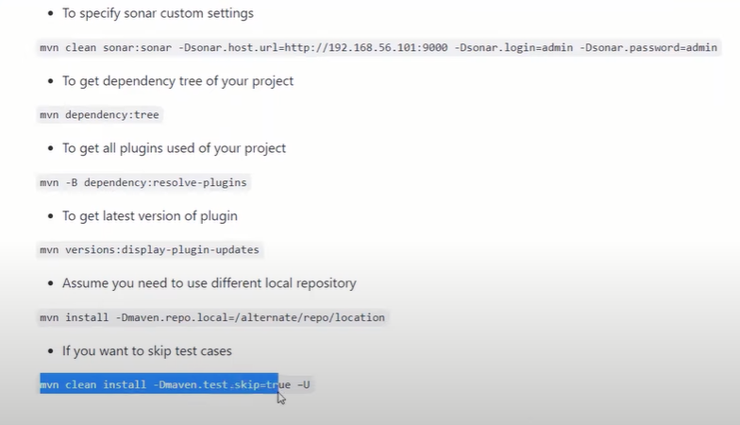
14) what is multi module project?
Reducing the duplication main reusability. let say for example you’re working on calculator project to develop that calculator has a basic functionality like addition subtraction multiplication etc. there are 2 ways one way like you club the code of all the operation and put it in a single code repository and you call that as calculator project and then you can give the product, but let assume to keep future in mind you may get the card project, there you might not need complex calculator modular operation, in that case you just need addition and subtraction in that time when you refer the calculator project on to that card project what will happen like but even thou if your using that calculator operation in card project and it makes really difficult to understand that code and you can’t reuse that code very efficiently so that’ where what we do, by following certain kind of rules we build the calculator project as multi module project in that (diff maven project) subproject addition and subtraction etc. projects are there. if you want addition project in card operation you can pick just addition project by referring artifact id group id and version of addition project in card project pom.xml you can use it true this reusability of code is very efficiently and reduce the duplication.
15) what is the importance of dependency management?
16) what are the settings that you need to do for mvn deploy ( to push artifacts to repository )?
17) mvn version that you have used?
18) Tell me 3 build lifecycle in maven? What does mvn site does?
19) Is there way by which we can set local repository as some other custom directory, other than .m2?
20) Settings that you make for mvn deploy?
21) What is the default value of packaging tag? What other values for other artifact types?
<packaging> default value is jar
For multimodal project <packaging>pom</packaging>, web application we can use war
22) What are GAV's?
In short form they may call groupid, artifactid & version as GAV’s let say you’re working on some specific project and some other person he want to use your project in there project then in that case they will ask you give me your GAV’s

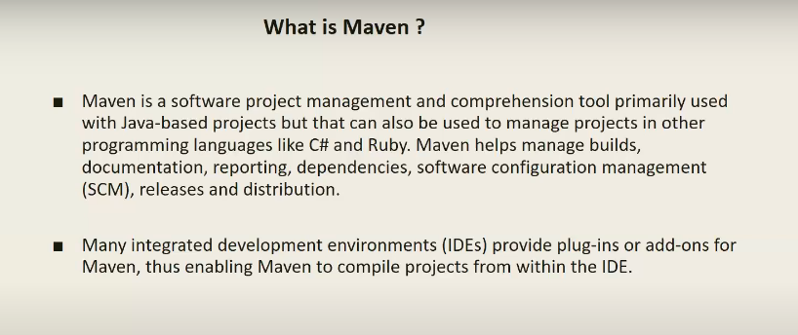
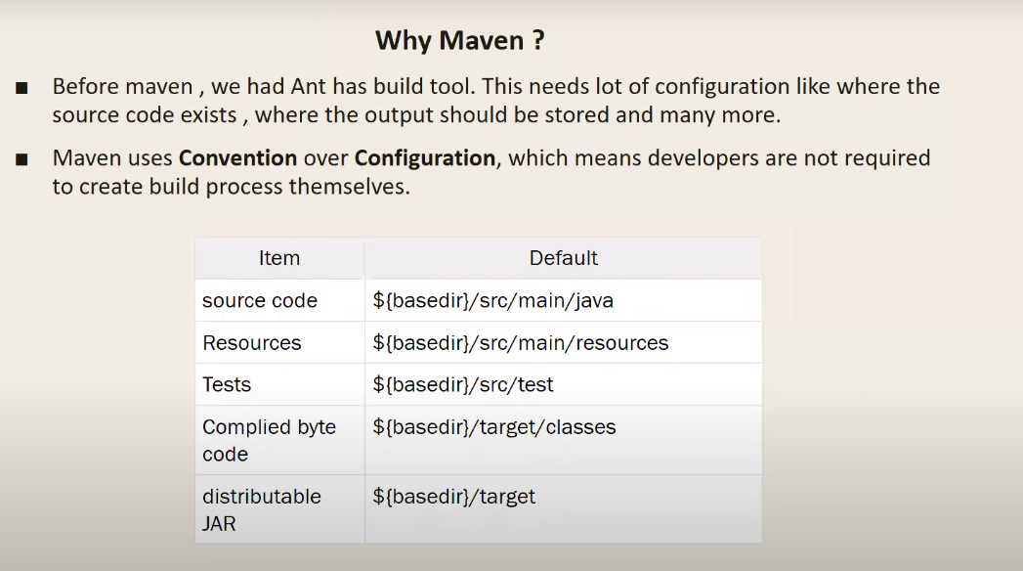
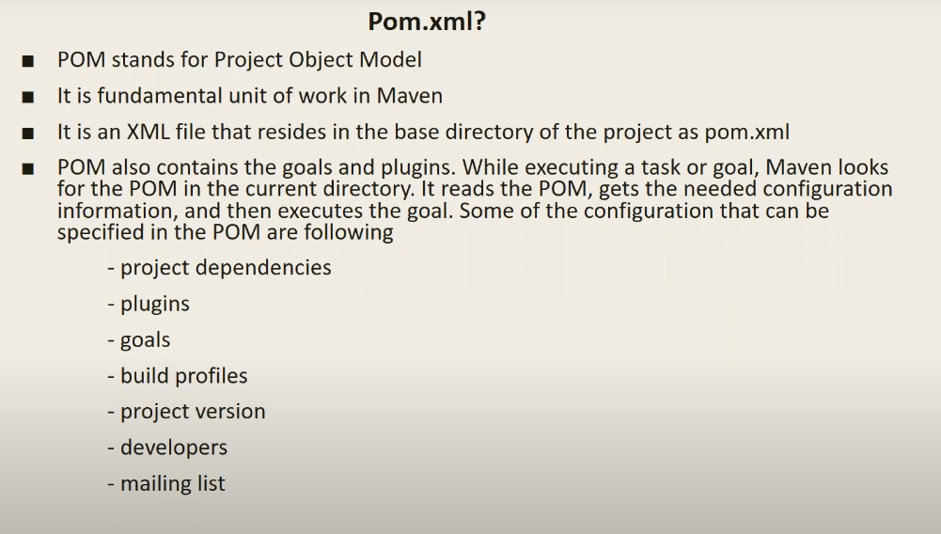
      - Where the pom.xml folder is there you want execute maven command there
      - Basically .m2 folder stored in root directory = cd ~/.m2

Got to repository -> junit -> you can see the versions of junit like that for all
------------------------------------------------------------------------------------------------------------------------------------------
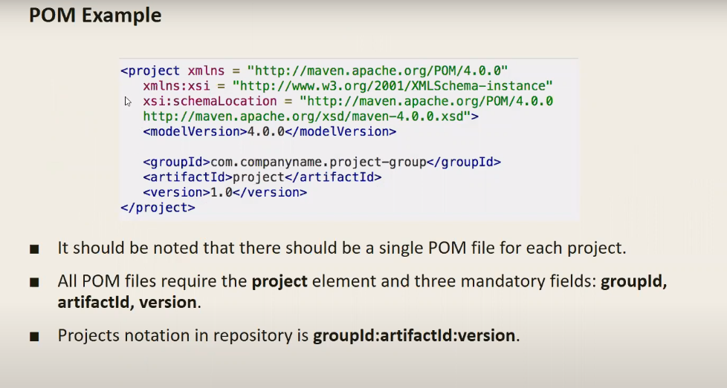
# but in pom we didn’t mention where my output should store and src path (source directory, test source directory, output directory) that’s where super pom comes into the picture
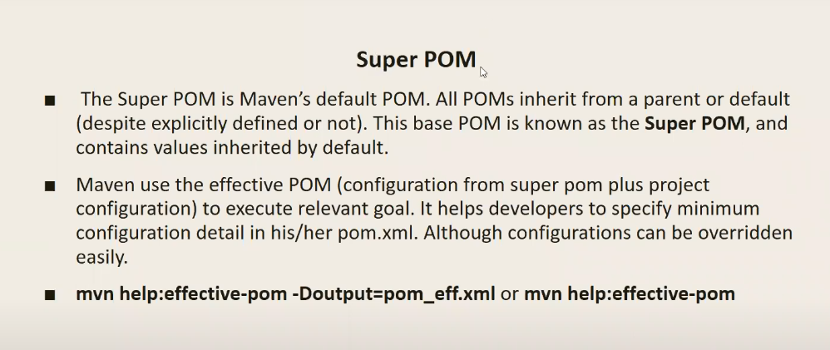
------------------------------------------------------------------------------------------------------------------------------------------
Clean – it clean the previous executed output (when you run mvn clean it will delete target folder)mvn site – it creates lot of documentation it help to manager to better view of your project (mvn site in target folder site directory created -> dependencies.html -> rightclick & open it in terminal [documentation] )
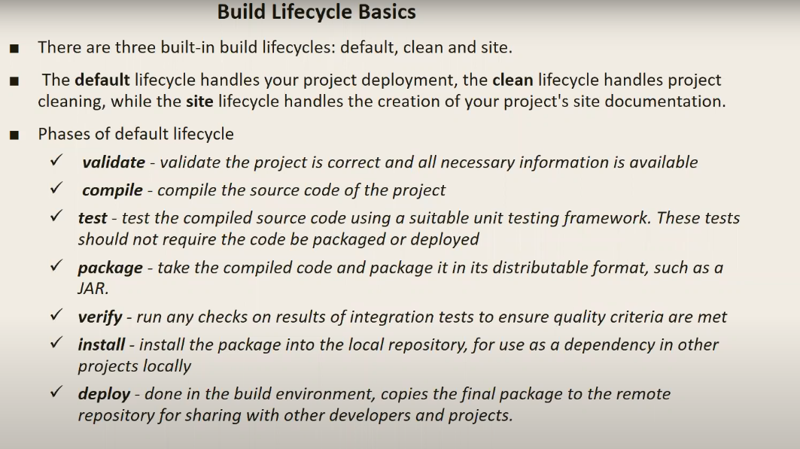

In deploy you need to mention where you need to deploy it (do some configuration in pom.xml file and setting.xml file)
In pom.xml <distributionManagement>
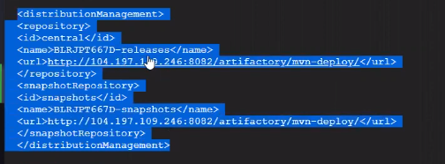
The credential you suppose to mention in settings.xml file
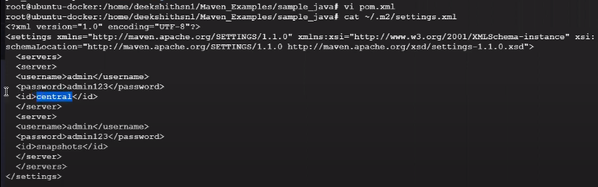
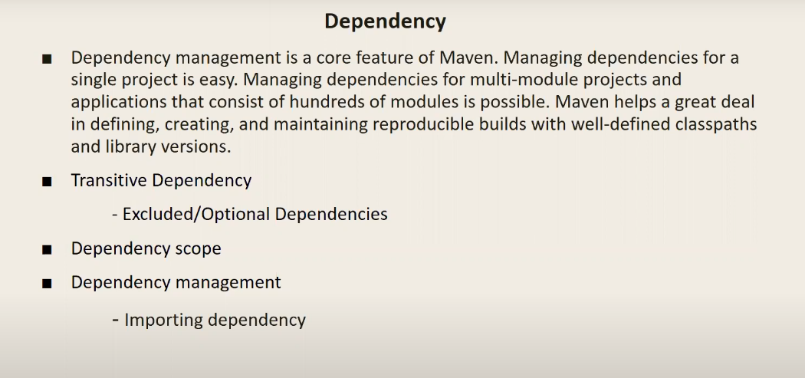
Transitive dependency –> junit as dependency to develop that they require another dependency
mvn dependency:tree -> command to view transitive dependency
If don’t want transitive dependency
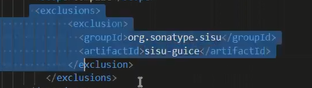

Dependency scope –> an which phase the particular plugin got execute
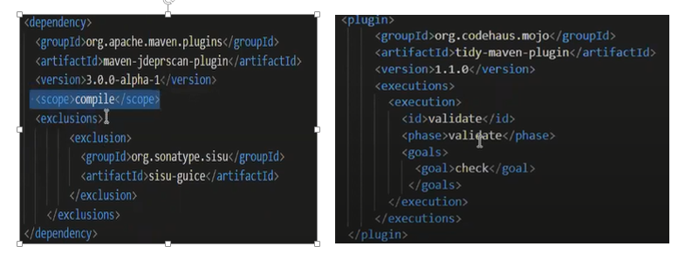

If you want to achive something extra feature
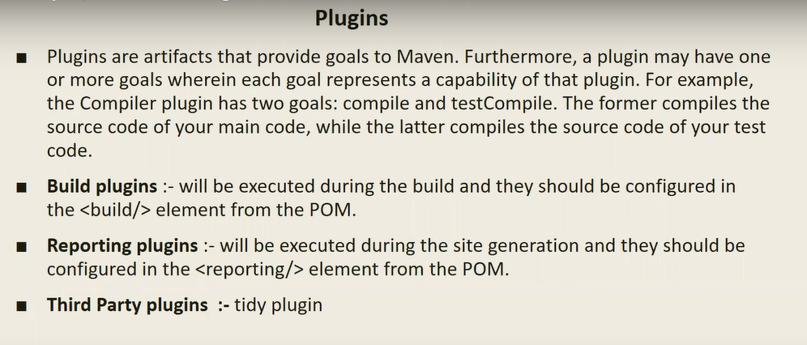

Standard order in pom.xml like <build> -> <plugin> -> <dependency> see calculater pom.xml file
* Third Party plugin :--If order is not standard we will get an error
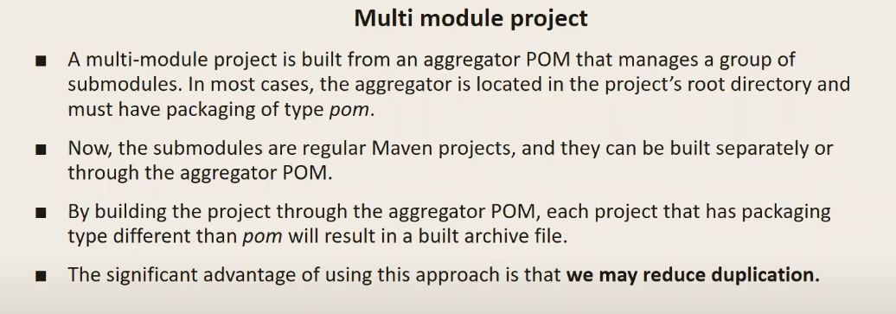

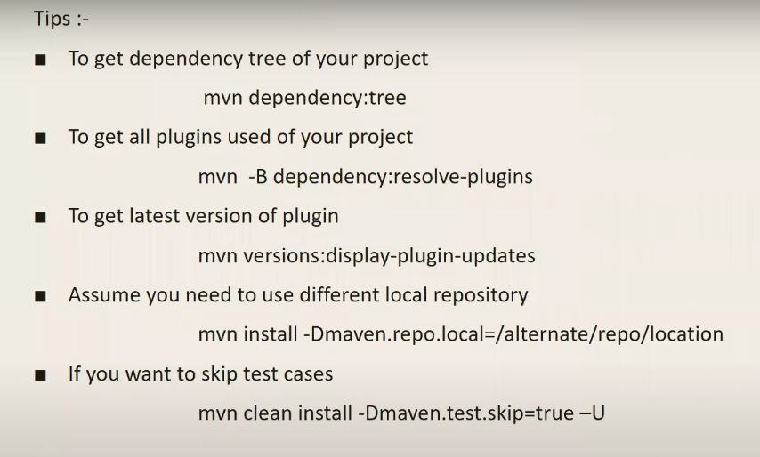
mvn install –Dmaven.repo.local=/home/ec2-user/build/vprofile-project/m2file

----------------------------------------------------------------------------------------------------------------------
So, we can say, plugin is a Jar file which executes the task, and dependency is a Jar which provides the class files to execute the task.

GRADLE (Android project)
* Gradle is based on groovy script but in maven we wright XML
* in XML you define configuration file (predefined XML tag) but gradle whatever you wright in build.gradle file is like language (scripting language) through that you can execute a task
* you can perform multi module project in gradle

Maven structure Gradle structure

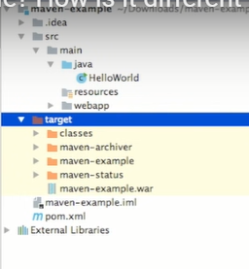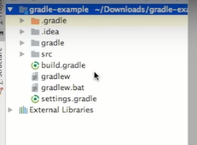

* Build.gradle similar to pom.xml file

After build in gradle ---


